Create your instance.

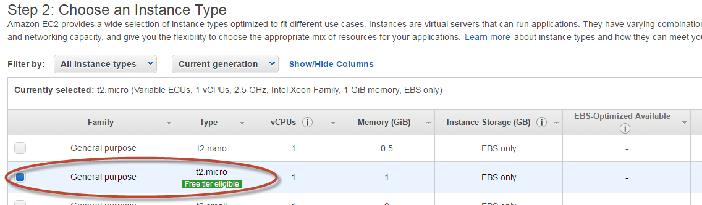

Figure : t2.micro is fine while it is free...

Not specific security group other than the default ‘launch wizard 1’, which currently allows access from any IP in the world.

Launch the Instance…

e.g.



(…)



____________________--

Other: Connecting to the instance via a console/terminal window. Use PuTTY.

1. You need to convert the (privateKey).pem file that was created when the instance was launched in the first place, and use PuTTYgen to load the key, convert it and save it again as a puTTY private key (.ppk file extension)
2. Launching PuTTY, ensure to connect to (Username@domain) e.g. [ec2-user@ec2-54-85-117-232.compute-1.amazonaws.com](mailto:ec2-user@ec2-54-85-117-232.compute-1.amazonaws.com), and ensure to load the .ppk file under the SSH>>AUTH section in PuTTY (AWS has pages to explain this clearly)
3. Connect to the instance should work from there to get a console window

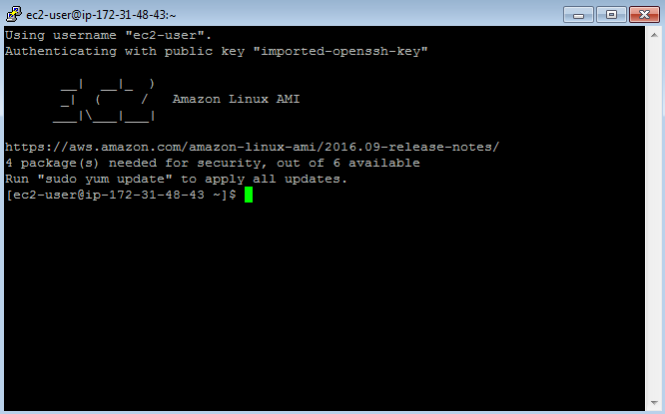

Download and install WinSCP, repeating the process to connect. This should lead to this

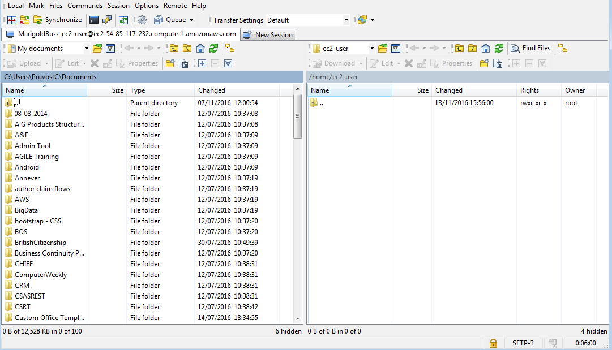

Secure copy of data to your EC2 instance. Via the command line.

**Transfer your .war file for deployment for example:**

Scp the file from your machine to your EC2 instance

|  |
| --- |
| C:\Users\pruvostc\My Documents\java>"C:\Users\pruvostc\My Documents\java>"C:\Program Files (x86)\PuTTY\pscp" -i "C:\Users\pruvostc\My Documents\AWS\EC2-tomcat\EC2-tomcat-for-PuTTY.ppk" thisisit.war ec2-user@52.16.124.169:/home/ec2-user/  thisisit.war | 227 kB | 227.9 kB/s | ETA: 00:00:00 | 100% |

Install the .war or .ear file in the tomcat ‘webapps’ folder, and (optional?) restart tomcat.

|  |
| --- |
| [ec2-user@ip-172-31-21-106 ~]$ sudo mv thisisit.war /usr/share/tomcat7/webapps/  [ec2-user@ip-172-31-21-106 ~]$ ls  [ec2-user@ip-172-31-21-106 ~]$ cd /usr/share/tomcat7/webapps/  [ec2-user@ip-172-31-21-106 webapps]$ ls -l  total 20  drwxr-xr-x 8 tomcat tomcat 4096 May 17 16:14 examples  drwxr-xr-x 3 tomcat tomcat 4096 May 17 16:14 ROOT  drwxr-xr-x 5 tomcat tomcat 4096 May 17 16:14 sample  drwxr-xr-x 4 tomcat tomcat 4096 May 30 14:28 thisisit  -rw-rw-r-- 1 ec2-user ec2-user 1493 May 30 14:27 thisisit.war  [ec2-user@ip-172-31-21-106 webapps]$ sudo service tomcat7 stop  [ec2-user@ip-172-31-21-106 webapps]$ [ OK ]  [ec2-user@ip-172-31-21-106 webapps]$ sudo service tomcat7 start  [ec2-user@ip-172-31-21-106 webapps]$ [ OK ]  [ec2-user@ip-172-31-21-106 webapps]$ |

For later automated uploads.

|  |
| --- |
| **Configuration location:**  cd /etc/httpd/conf.d if need to edit configurations.  [ec2-user@ip-172-31-21-106 webapps]$ cd /etc/httpd/conf.d  [ec2-user@ip-172-31-21-106 conf.d]$ grep thisisit *  proxy.conf:ProxyPass /thisisit http://localhost:8080/thisisit  proxy.conf:ProxyPassReverse /thisisit http://localhost:8080/thisisit  **content location:**  cd /var/www/marigoldbuzz.com/ to edit content directly on http server |